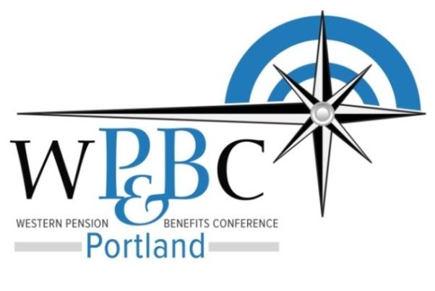

HEALTH, WELFARE, & Benefits Symposium

Wednesday, January 28, 2015
8:00 AM – 11:30 AM Pacific Time

Presenter Biographies
Steven Nofziger, Garvey, Schubert, Barer Law, snofziger@gsblaw.com
Steven Nofziger focuses his practice on advising clients on employee benefits, taxation and business planning matters.
Mr. Nofziger assists clients in designing and implementing qualified and nonqualified deferred compensation, retirement and welfare benefit plans, advising on plan administration, ERISA compliance and fiduciary issues and correcting operational errors. He also advises clients on the impact of health care reform under the Affordable Care Act (ACA) and assists in related planning and compliance matters. He assists clients with business and tax planning matters, including business entity formation and ownership transfers, tax and compensation planning (including executive compensation matters), worker classification, IRC § 1031 exchanges and federal, state and local tax controversies (i.e., audits and appeals).
Mr. Nofziger is a frequent speaker and author on tax and employee benefit matters. Prior to pursuing a law degree, Mr. Nofziger worked as an underwriter of life and disability insurance for employee benefit plans. During this time, he also earned his certification as a Certified Employee Benefit Specialist.
Sarah Friend, The Partner Group, Sarah@tpgrp.com
Sarah Friend has worked in the health insurance industry for 19 years and specializes in working with large, complex employers. Before joining The Partners Group in 2007, Sarah worked with one of Oregon’s leading health plans in a variety of sales, operation and management positions.

Sarah graduated from Western Oregon University with a degree in Communication and Business. Sarah volunteers frequently in the community. Sarah is married with three children and loves to spend time with family at the southern Oregon coast, water skiing and enjoying time together.

Dr. Prasanna Krishnasamy, MD, MPH, Legacy Health, pkrishna@LHS.org
Dr. Krishnasamy believes in a holistic approach to patient care - emphasizing the roles of social, mental, and environmental factors influencing health and wellbeing. He works part time as a Physician, part time as the Medical Director for Medical Home transformation, and part time as a Faculty member in the Legacy Residency program. He is certified by the American Board of Internal Medicine and is an active member of the American College of Physicians. His clinics are recognized as a fully functioning Medical Home both at the State and National level. Hobbies include: Running, Hiking, and Photography

Dr. Krishnasamy attended medical school at Coimbatore Medical College, Tamilnadu Medical University, India

Merrin Permut, MHA, Legacy Health, mpermut@LHS.org
Merrin Permut joined Legacy Health in 2010 and is the Executive Director of Legacy Health Partners (LHP), a partnership between independent private practice physicians, Legacy Health and Legacy Medical Group. Merrin has led the development of LHP for the past two years. Prior to joining LHP, Merrin worked in strategic planning and has managed multiple programs for the organization including Meaningful Use, Master Facility Planning and Coordinated Care Organization (CCO) development. As part of her work on CCO development, Merrin was temporarily loaned to assist in the startup of Health Share of Oregon and worked on provider and payor contracts. Before joining Legacy Health, she was a consultant for a Chicago-based public affairs firm.
Ms. Permut received her Masters of Healthcare Administration from the University of Minnesota.
Jackie Ross, Legacy Health, jaross@LHS.org
Jackie Ross has background in healthcare administration. Prior to becoming the medical home program manager, Ms. Ross was a clinic supervisor for Ortho and Pain Management at Legacy. Ms. Ross has worked in medical home for 8 years. Ms. Ross has a desire to improve care across the continuum for patients of all ages.
Chris Briggs, Stoel Rives, chris.briggs@stoel.com
Chris Briggs is a partner in the firm's Employee Benefits practice section. His practice focuses on all aspects of employee benefits, including qualified retirement plans, nonqualified deferred compensation plans, health and welfare plans, and fringe benefits plans. He also focuses on executive compensation matters, including the impact of Internal Revenue Code Section 409A. In addition, Chris has extensive experience advising clients on benefits issues presented by mergers and acquisitions.
Chris regularly assists government entities with their unique benefits issues, including Internal Revenue Code 403(b) and 457(b) plans, grandfathered Internal Revenue Code 401(k) plans and the requirements of Internal Revenue Code Section 457(f).
In addition, Chris helps public and private companies comply with regulatory matters, including ERISA, the Internal Revenue Code and underlying regulations. He also assists clients in petitioning the IRS or DOL for relief when these regulations have not been satisfied.
Kiran Griffith, Stoel Rives, kiran.griffith@stoel.com
Kiran Griffith is an associate in the Employee Benefits group. Kiran's practice focuses on advising clients on employee benefit matters including health and welfare plans, executive compensation, qualified retirement plans, and profit sharing and incentive plans.
Prior to joining the firm, Kiran was a summer associate with Stoel Rives and a senior compliance manager with the Gerson Lehman Group.

Presentation materials available for viewing or download at: http://wpbcportland.org

